Check You tube link : <https://www.youtube.com/watch?v=CI0gT8uI3fE&list=PLmHi7ol7EPSCqpkQ3DdZuBpPHoBWh7caz&index=6>

Combine more than 1 excel sheet’s data into one excel sheet using power Query Append Method.

Steps:

1. Firstly make your data into tables by pressing control +T
2. Go to Data Tab and select get data from table/range
3. Power Query editor will get opened, select add column

Eg.

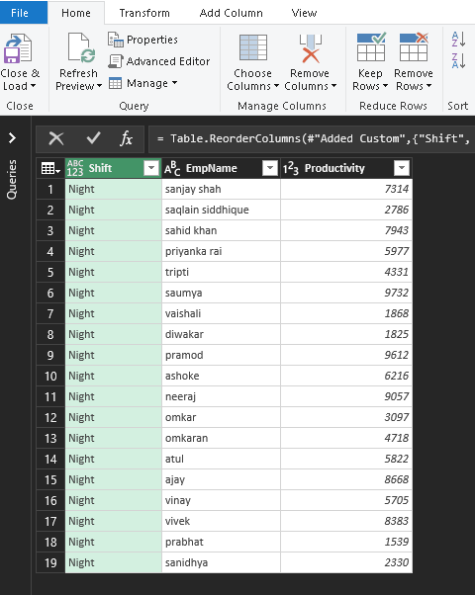

After adding columns , don’t choose close and load option instead you must choose close and load to …. Wala option to create connections

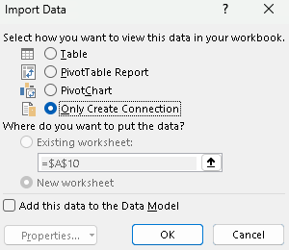

When you choose cload and load to.. then an window will be opened …

Select only create connection and press ok

1. Follow the same steps for another 3 sheets …

Then all your connetion will be shown on right side of screen



Afer all that … you can right click over any table shown upside

An window will be opened



Select append.. you can also go to data tab🡪 combine queries

And select append

